Returns & Portfolio Mathematics
From Prices to Portfolio Risk
A Level 2 module in the Quantitative Finance Curriculum
Covers: simple & log returns · arithmetic vs geometric returns · cumulative returns · annualisation · volatility scaling · portfolio weights, expected return & variance · diversification · risk contribution & marginal contribution to risk

Table of Contents

How to Use This Guide
This document is a companion to Returns & Portfolio Mathematics, the second-level module in the quantitative finance curriculum. It covers the arithmetic that turns raw prices into returns, and turns returns into portfolio-level risk and reward — the measurement layer that sits underneath every performance number, backtest, and risk report used later in the curriculum.
The module is self-contained: every formula is introduced from first principles, paired with a short runnable Python sketch, and — wherever a picture makes the idea land faster than an equation — a chart. Read it start to finish if you are new to the topic, or jump straight to the section you need.

What you need to know before starting
- Arithmetic and algebra — comfort manipulating ratios, exponents, and logarithms.
- Linear algebra — vectors, matrices, and matrix multiplication, needed for portfolio variance (wᵀΣw).
- A little Python and NumPy — the code sketches use array operations rather than loops.
Tip: You don't need a finance background to start here — every term is defined the first time it appears. What you do need is to be comfortable with logs, sums, and matrix-vector notation.

Why it matters
Every Sharpe ratio, every backtest P&L curve, every risk report a trading desk reads is built from the definitions in this module. Get the return convention or the annualisation factor wrong, and every number downstream — performance attribution, risk budgets, strategy comparisons — is wrong too, often silently, because a mis-scaled number still looks like a plausible number.

How this connects to the rest of the curriculum
- Research — signal evaluation and backtest P&L are computed entirely in this framework: every Sharpe ratio, hit rate, and drawdown statistic starts from a return series.
- Development — return and volatility calculation utilities are typically the first reusable modules in any research codebase (see `src/` conventions in Part VIII of the curriculum).
- Trading — position-level and portfolio-level risk contribution drive real-time hedging and sizing decisions on a live book.

Glossary of recurring terms
Simple return — The percentage change in price over one period: (P_t − P_{t-1}) / P_{t-1}.
Log return — The natural logarithm of the price ratio: ln(P_t / P_{t-1}); also called the continuously compounded return.
Arithmetic mean return — The simple average of a series of period returns; used for expected-return inputs to a one-period optimisation.
Geometric mean return — The constant per-period return that would have produced the same cumulative growth; always ≤ the arithmetic mean when returns are volatile.
Cumulative return — The total compounded growth of an investment over many periods, found by chaining (not averaging) individual period returns.
Annualisation — Rescaling a return or volatility measured over one frequency (daily, monthly) to a common one-year basis, so figures measured on different clocks can be compared.
Volatility (σ) — The standard deviation of returns; the standard measure of how much an asset's return fluctuates around its mean.
Covariance / correlation — Covariance measures how two assets' returns move together in absolute units; correlation is covariance normalised to the range [-1, 1], which is why it is easier to interpret at a glance.
Covariance matrix (Σ) — A matrix whose entries describe how every pair of asset returns moves together; the core input to portfolio variance.
Portfolio weight (w_i) — The fraction of total portfolio value invested in asset i, with Σw_i = 1 for a fully-invested portfolio.
Diversification — The reduction in portfolio risk that comes from combining assets that are not perfectly correlated, beyond what a simple weighted average of their individual risks would suggest.
Systematic vs. idiosyncratic risk — Idiosyncratic risk is specific to one asset and can be diversified away by holding more positions; systematic risk is shared across all assets (via non-zero average correlation) and cannot be diversified away.
Risk contribution — The share of total portfolio volatility attributable to a single position, accounting for its correlation with everything else in the book.
Marginal contribution to risk (MCR) — The rate at which total portfolio volatility changes for a small change in one asset's weight — the sensitivity ∂σ_p/∂w_i.

Part 1 — Returns & Portfolio Mathematics
This part builds the toolkit every later module relies on: how to turn a price series into a return series, how to summarise many periods of returns into one honest number, and how to move from single-asset statistics to portfolio-level risk. If you are new to quantitative finance, start here and work through the sections in order.

1.1 Simple vs. Log Returns
There are two standard ways to express the change in an asset's price from one period to the next. Which one you use changes how returns should be averaged, compounded, and annualised — so the choice matters far beyond notation.
- Simple return — the percentage change in price, and the natural convention for describing what an investor actually earned or lost:
R_t = (P_t − P_{t-1}) / P_{t-1}
- Log return — the natural logarithm of the price ratio, also called the continuously compounded return:
r_t = ln(P_t / P_{t-1}) = ln(1 + R_t)
Log returns are additive across time: the log return over two periods is simply the sum of the two one-period log returns, r_{1→2} = r_1 + r_2. This makes them convenient for statistical modelling, simulation, and multi-period aggregation. Simple returns are additive across assets at a point in time — a portfolio's simple return is the weight-average of its constituents' simple returns, R_p = Σ w_i R_i — which makes them the natural convention for portfolio-level calculations. Most desks use log returns for time-series statistics and simple returns for cross-sectional portfolio maths, converting between the two as needed.
Worked example. A stock moves from $100 to $103 in one day. The simple return is R = 103/100 − 1 = 3.00%. The log return is r = ln(103/100) = 2.956%. Now suppose it moves from $100 to $150 — a much larger move. The simple return is 50.00%, but the log return is ln(1.5) = 40.55%. The gap between the two widens as the price move gets larger, which is exactly what the chart below shows: near a price ratio of 1 (small moves) the two measures are almost identical, but they diverge noticeably for large moves — and log returns are always the smaller (more conservative) number for a gain, and the less negative number for a loss.
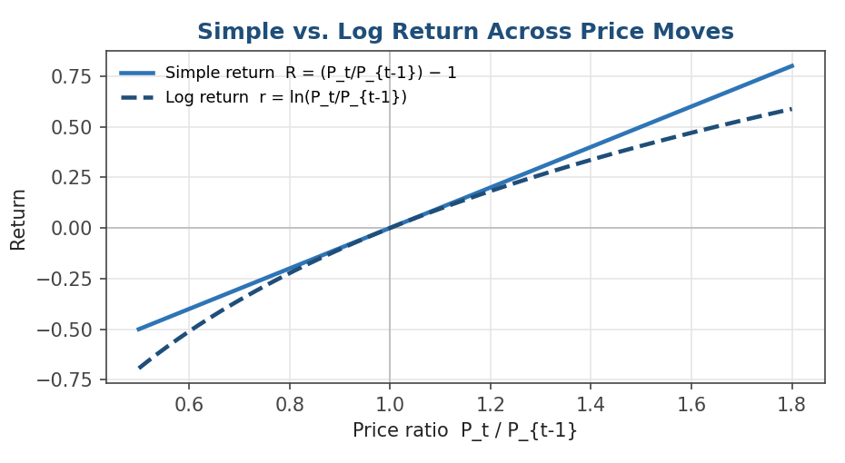
Figure 1.1 — Simple and log returns agree closely for small price moves but diverge for large ones; log returns are bounded below at −∞ (a price can never go negative) while simple returns are bounded at −100%.
Why this matters in practice: Because a log return of −∞ corresponds to a price of exactly zero, log returns naturally rule out a price going negative — something a simple return has no built-in way to prevent. Combined with the fact that they compound by simple addition, this makes log returns the standard choice inside Monte Carlo simulations and GARCH-style volatility models, anywhere returns need to be summed or drawn from a symmetric distribution without accidentally implying a negative price.
import numpy as np
prices = np.array([100.0, 101.5, 99.8, 103.2, 104.0])
simple_returns = prices[1:] / prices[:-1] - 1
log_returns = np.log(prices[1:] / prices[:-1])

1.2 Arithmetic vs. Geometric Returns
Once you have a series of period returns, there are two different ways to summarise them into a single 'average return' — and they answer two different questions.
- Arithmetic mean — the simple average of the period returns. It answers: what return should I expect in a single, randomly chosen period? It is the right input for a one-period mean-variance optimisation, because expectation is a linear operator and the arithmetic mean is an unbiased estimator of the single-period expected return.
R_arith = (1/T) · Σ R_t
- Geometric mean — the constant per-period return that would have compounded to the same total growth actually observed. It answers: what did this investment actually earn me per period, on average, over the whole history?
R_geom = [ Π (1 + R_t) ]^(1/T) − 1
Because of Jensen's inequality applied to the concave logarithm function, the geometric mean is always less than or equal to the arithmetic mean whenever returns are volatile, and the gap between them — often called volatility drag — grows with variance, approximately R_geom ≈ R_arith − ½σ². A strategy with a 10% arithmetic mean return and 45% annualised volatility can have a geometric (realised) return close to zero, even though the 'average return' reported in a slide deck still says 10%.
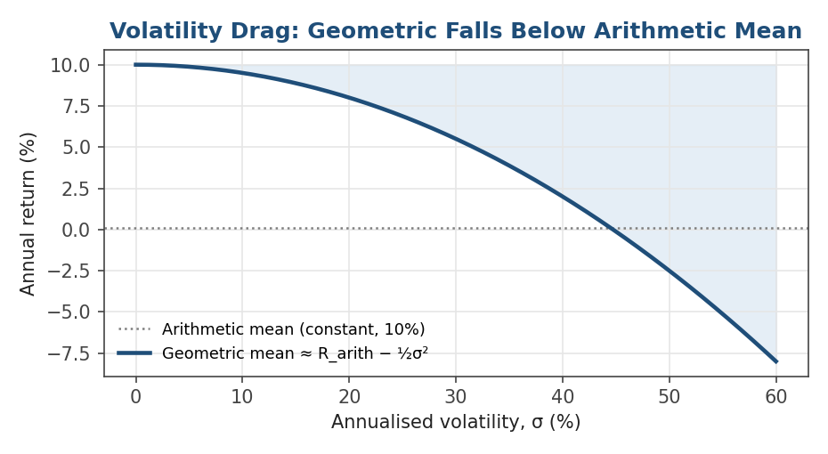
Figure 1.2 — Holding the arithmetic mean fixed at 10%, the realised (geometric) compound return falls steadily as volatility rises, and can turn negative at high enough volatility.
Worked example. A stock returns +50% in year one and −50% in year two. The arithmetic mean is (50% − 50%) / 2 = 0%, suggesting the investment broke even. But $100 invested becomes $150 after year one, then $75 after year two — a 25% loss overall. The geometric mean is √(1.5 × 0.5) − 1 = −13.4% per year, which correctly reflects the actual outcome. This is an extreme illustration of exactly the same drag shown in the chart above.
Common mistake: Quoting the arithmetic mean of a volatile strategy's returns as if it were the compounded growth rate an investor actually experienced. Performance reporting should always be explicit about which mean is being quoted, and should lead with the geometric (realised) figure when describing what was actually earned.

1.3 Cumulative Returns
Turning a series of period returns into total growth requires compounding, not averaging. For simple returns, chain the growth factors (1 + R_t) together; for log returns, simply sum them and exponentiate at the end — the two approaches are mathematically identical, just expressed in different units.
Cumulative growth = Π_{t=1}^{T} (1 + R_t) = exp( Σ_{t=1}^{T} r_t )
The cumulative return is that growth factor minus one. Because compounding is multiplicative and not additive, a naive running sum of period returns will drift away from the true cumulative return as soon as returns are non-trivial in size — the two only agree exactly in the limit of infinitesimally small returns. This distinction is the single most common source of error for anyone new to performance measurement, and it is the reason cumulative return curves are built as running products (or running sums of log returns), never as running averages or running sums of simple returns.
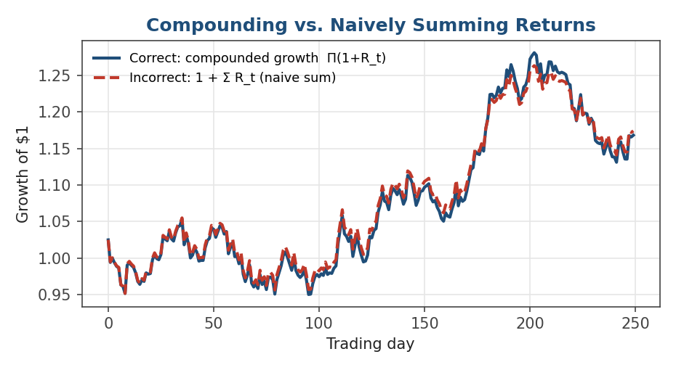
Figure 1.3 — A correctly compounded growth curve (navy) versus the common but incorrect shortcut of naively summing simple returns (red dashed). The two tracks stay close for small daily moves but visibly separate as the series lengthens.
cumulative_growth = np.cumprod(1 + simple_returns)
# equivalently, using log returns:
cumulative_growth_log = np.exp(np.cumsum(log_returns))
total_return = cumulative_growth[-1] - 1

1.4 Annualisation
Returns and volatilities are usually measured on whatever frequency the data comes in — daily, weekly, monthly — but are almost always reported on an annual basis so that strategies and asset classes can be compared on a common clock. The core idea is to scale a per-period figure by the number of periods in a year, but the correct operation depends on whether you are annualising a return (compounding) or a volatility (a statistical scaling law, covered in 1.5).
- For log returns, annualise by simply multiplying the mean by the number of periods per year (log returns are additive over time):
r_annual = r_period · N where N = periods per year
- For simple returns, annualise by compounding the mean growth factor over N periods:
R_annual = (1 + R_period)^N − 1
The value of N depends entirely on the frequency of the underlying data, and using the wrong one is one of the most common — and most silent — errors in performance reporting, because a mis-annualised number is still a plausible-looking number.
Data frequency | Periods per year (N)
Daily (trading days) | ≈ 252
Daily (calendar days) | 365
Weekly | 52
Monthly | 12
Quarterly | 4
Annual | 1

Common mistake: Annualising volatility with the wrong scaling factor for the data's frequency — for example applying √252 scaling to weekly return data, or annualising monthly log returns by multiplying by 252 instead of 12. Always match N to the actual number of periods per year in your data, never assume a default.

1.5 Volatility Scaling
Volatility does not compound the way returns do. Under the standard assumption that period returns are independent and identically distributed (i.i.d.), variance is additive across time — Var(r_1 + r_2) = Var(r_1) + Var(r_2) when the two are independent — which means volatility (its square root) scales with the square root of time rather than linearly.
σ_annual = σ_period · √N
This √N (or 'square-root-of-time') rule is the reason a strategy's daily volatility of, say, 1.5% becomes roughly 24% annualised (1.5% × √252 ≈ 23.8%), not 378% (1.5% × 252) as naive linear scaling would suggest. It relies squarely on the i.i.d. assumption — if returns are autocorrelated (which real returns often are, especially at short horizons, due to effects like momentum or mean reversion), naive √N scaling will over- or under-state true annualised risk, and a more careful estimator that accounts for the autocorrelation structure is needed.
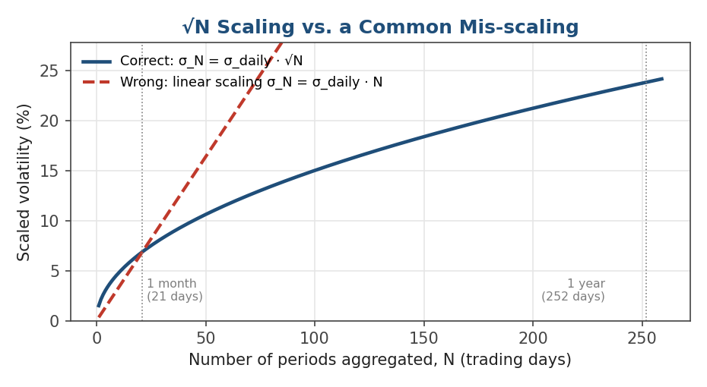
Figure 1.4 — Correct √N volatility scaling curves upward but flattens as N grows, while a mistaken linear scaling (sometimes applied by confusing the return-annualisation rule with the volatility rule) overstates risk dramatically at longer horizons.
daily_vol = log_returns.std(ddof=1)
annual_vol = daily_vol * np.sqrt(252)

1.6 Portfolio Weights, Expected Return, and Variance
A portfolio is fully described, at the mathematics level, by a vector of weights allocated across assets. Everything else — expected return, variance, diversification, risk contribution — follows from combining those weights with the assets' expected returns and covariance structure.
- Weights — the fraction of portfolio value in each asset, typically constrained to sum to one for a fully-invested, unlevered portfolio (long-only strategies further constrain each w_i ≥ 0; long-short books relax this and allow negative weights):
Σ w_i = 1
- Expected portfolio return — the weight-average of the assets' expected returns, written compactly with vector notation (w and μ as column vectors):
E[R_p] = wᵀ μ = Σ_i w_i μ_i
- Portfolio variance — this is where correlation enters, and where portfolio mathematics stops being a simple average. It depends on the full covariance matrix Σ, whose off-diagonal entries capture how pairs of assets move together:
σ_p² = wᵀ Σ w = Σ_i Σ_j w_i w_j σ_ij
Expanding the double sum for a simple two-asset portfolio makes the mechanics concrete: σ_p² = w_1²σ_1² + w_2²σ_2² + 2w_1w_2σ_1σ_2ρ_{12}, where ρ_{12} is the correlation between the two assets. The last term is the only place correlation enters, and it is the entire reason portfolio variance is not just a weighted average of individual variances.
Worked example. Two assets each have 20% annualised volatility and equal 50% weights. If they are perfectly correlated (ρ = 1), portfolio volatility is also 20% — no benefit from combining them. If they are uncorrelated (ρ = 0), portfolio variance is 0.5² × 0.20² + 0.5² × 0.20² = 0.02, giving portfolio volatility of √0.02 ≈ 14.1% — meaningfully lower than either asset held alone. If they are negatively correlated (ρ = −0.5), portfolio volatility falls further, to about 10%. The weights and individual risks never changed; only the correlation did.
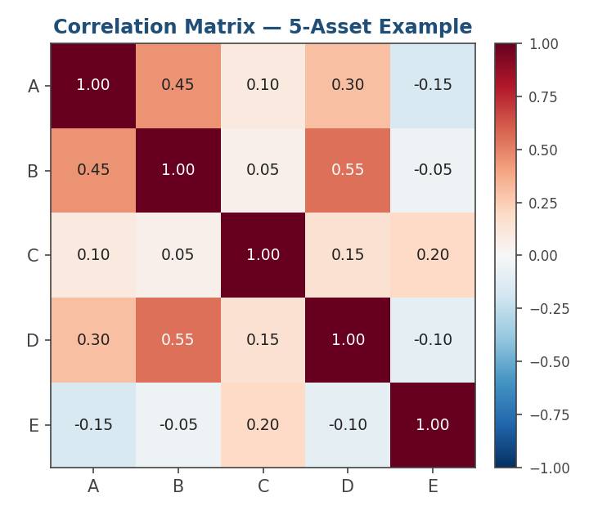
Figure 1.5 — A correlation matrix for a 5-asset portfolio. Diagonal entries are always 1 (an asset is perfectly correlated with itself); off-diagonal entries closer to 1 (dark red) mean two assets move together, and closer to −1 (dark blue) mean they move oppositely.
mu = np.array([0.08, 0.10, 0.06, 0.12, 0.05]) # expected annual returns
Sigma = np.cov(returns_matrix, rowvar=False) # 5x5 covariance matrix
w = np.array([0.25, 0.20, 0.15, 0.25, 0.15])
expected_return = w @ mu
portfolio_variance = w @ Sigma @ w
portfolio_vol = np.sqrt(portfolio_variance)

1.7 Diversification
Diversification is the mathematical fact, visible directly in the wᵀΣw formula above, that combining assets whose returns are not perfectly correlated reduces portfolio risk below the weight-average of their individual risks. The lower the pairwise correlations, the greater the reduction — a portfolio of perfectly correlated assets (ρ = 1) gets no diversification benefit at all, while assets with negative correlation can reduce risk dramatically.
σ_p ≤ Σ_i w_i σ_i (equality only when all pairwise correlations equal 1)
A classic way to see this is to hold N equally-weighted, equally-risky assets with the same average pairwise correlation and let N grow. As the chart below shows, portfolio variance decomposes into an idiosyncratic piece that shrinks toward zero as 1/N, and a systematic piece — driven entirely by the average covariance between holdings — that does not shrink, no matter how many assets are added.
σ_p² = (avg. variance − avg. covariance) / N + avg. covariance
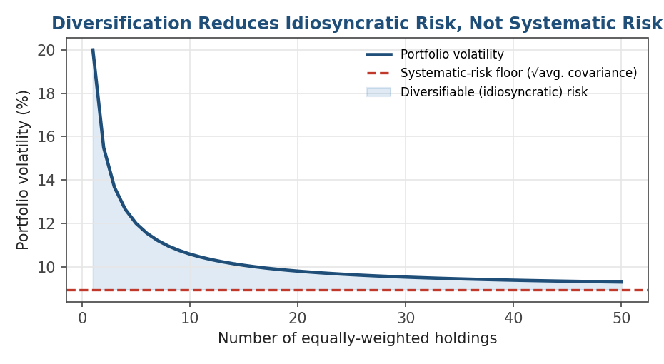
Figure 1.6 — Portfolio volatility falls quickly as the first handful of holdings are added, then flattens out toward a floor set entirely by the average correlation between assets — the systematic risk that no amount of further diversification can remove.
This single chart is the mathematical justification for holding many imperfectly-correlated positions rather than concentrating in the single asset with the best expected return — but it also shows the limit of the strategy: past roughly 15–20 holdings in this example, adding more names buys very little further risk reduction, because what remains is systematic, not idiosyncratic, risk. This is the starting point for classical mean-variance portfolio construction, covered in later modules.
Tip: The number of holdings needed to capture most of the diversification benefit depends on the average correlation, not on some fixed rule of thumb. Highly correlated asset classes (e.g. large-cap equities within one sector) flatten out quickly with few names; low-correlation combinations (e.g. equities plus government bonds plus commodities) continue to offer benefits well beyond 20 names.

1.8 Risk Contribution & Marginal Contribution to Risk
Portfolio variance tells you the total risk of the book, but a trader or risk manager usually needs to know where that risk is coming from — which positions are driving the number, and by how much. This is answered by decomposing total portfolio volatility into contributions from each position.
- Marginal contribution to risk (MCR) — how much total portfolio volatility changes for a small change in one asset's weight, i.e. the partial derivative of σ_p with respect to w_i. Because Σw is the vector of each asset's covariance with the whole portfolio, MCR is naturally larger for assets that are highly correlated with the rest of the book:
MCR_i = ∂σ_p / ∂w_i = (Σw)_i / σ_p
- Risk contribution (RC) — scaling the marginal contribution by the position's actual weight gives the portion of total volatility attributable to that position. A convenient property of this decomposition — a direct consequence of Euler's theorem, since σ_p is homogeneous of degree one in the weights — is that the risk contributions sum exactly to total portfolio volatility:
RC_i = w_i · MCR_i and Σ_i RC_i = σ_p
Expressed as a percentage of total risk (RC_i / σ_p), this decomposition is the basis of risk budgeting: instead of asking 'how much capital is allocated to each position', a risk manager asks 'how much of my total risk budget is each position consuming' — and the two questions can have very different answers when positions are correlated. A position can carry a modest weight but a large risk contribution because it is highly correlated with the rest of the book (a concentrator), or a large weight but a small risk contribution because it hedges the rest of the portfolio (a diversifier).
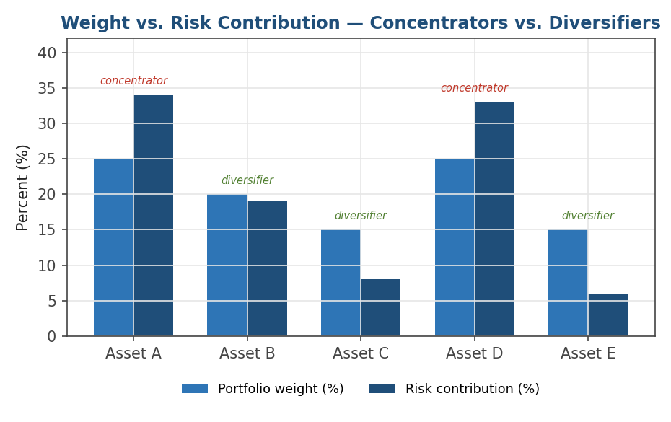
Figure 1.7 — Comparing each asset's portfolio weight against its share of total risk. Assets A and D carry outsized risk relative to their weight (concentrators, likely highly correlated with the rest of the book); Assets C and E carry less risk than their weight would suggest (diversifiers).
sigma_p = np.sqrt(w @ Sigma @ w)
mcr = (Sigma @ w) / sigma_p # marginal contribution to risk
rc = w * mcr # risk contribution per asset
rc_pct = rc / sigma_p # should sum to 1.0
assert np.isclose(rc.sum(), sigma_p)
Tip: A position can have a small weight but a large risk contribution if it is highly correlated with the rest of the book — and, conversely, a large weight but small (even negative) risk contribution if it is a good diversifier. Always check both numbers before assuming a position is 'small', and remember that a negative risk contribution is possible: a position that is negatively correlated with the rest of the book can actually reduce total portfolio volatility.

Practical Exercise
Work through the following with a 5-asset portfolio of your choice (real or simulated daily price data covering at least a year):
- Compute daily log returns for each of the five assets, and plot them to sanity-check for obvious data errors (stale prices, stock splits not adjusted for, etc.).
- Estimate the annualised volatility of each asset using the √N scaling rule from Section 1.5, and compare it against a rolling 21-day (one-month) estimate to see how much volatility varies over time.
- Build the 5×5 covariance matrix (and the corresponding correlation matrix) of daily log returns, and pick a set of weights that sum to one.
- Compute the portfolio's expected annual return and annualised volatility, using both the arithmetic and geometric mean of each asset's returns as the expected-return input — compare the two portfolio-level results.
- Compute each asset's marginal contribution to risk and risk contribution, and confirm numerically that the risk contributions sum to the portfolio volatility.
- Compare each asset's weight to its risk-contribution percentage — identify which positions are diversifiers and which are risk concentrators, and consider how you might rebalance to reduce concentration.

Common Beginner Mistakes
Mistake 1 — Wrong scaling factor: Annualising volatility with the wrong scaling factor for the data's frequency — always match √N to the actual number of periods per year in your data, not a default assumption of 252.
Mistake 2 — Averaging instead of compounding: Averaging simple returns across time instead of compounding them — a return series must be chained with cumulative products (or summed as log returns), never averaged, to get total growth.
Mistake 3 — Ignoring correlation in portfolio risk: Treating portfolio volatility as a weighted average of individual asset volatilities. It is not — it depends on the full covariance matrix, and ignoring correlation will misstate risk in either direction depending on whether the true correlations are higher or lower than assumed.
Mistake 4 — Confusing weight with risk: Assuming a small position is automatically a small risk. A highly correlated small position can contribute disproportionately to total portfolio risk — always check risk contribution, not just weight.

Advanced Extensions
Once this module is comfortable, the natural next step (Level 3) is risk parity and Equal Risk Contribution (ERC) portfolios — constructions where weights are chosen specifically so that every position's risk contribution, computed exactly as in Section 1.8, is equal. This turns the risk-contribution formula from a diagnostic tool into a portfolio-construction objective, and typically requires solving a numerical optimisation problem rather than a closed-form solution, because the risk contribution of each asset depends on every other asset's weight simultaneously.

Professional Applications
- Performance reporting — correctly distinguishing arithmetic from geometric returns, and reporting cumulative performance via compounding, not averaging.
- Risk budgeting — allocating a firm's or desk's risk capacity across strategies and positions using marginal and total risk contribution, rather than notional exposure alone.
- Strategy comparison — putting return and volatility figures from different data frequencies on the same annualised footing before comparing Sharpe ratios across strategies.

Where to Go Next
This module is the measurement layer for everything that follows in the curriculum: backtesting, risk management, and portfolio construction all assume the definitions and conventions introduced here. Before moving on, make sure you are comfortable converting fluently between simple and log returns, and between per-period and annualised figures — the rest of the curriculum will use both without re-deriving them.

Suggested paths depending on your focus
- Heading into backtesting / research: move on to signal evaluation and Sharpe-ratio-based strategy comparison, which build directly on Sections 1.1–1.4.
- Heading into risk management: go to Level 3's risk parity and Equal Risk Contribution portfolios, which extend Section 1.8 into a full portfolio-construction method.
- Heading into trading: focus on Sections 1.6–1.8 — portfolio variance and risk contribution are exactly what drives real-time hedging and position-sizing decisions on a live book.

